

The Dating Game:
Searching for Liquidity in the New Economy
or
Sex, Liquidity and the New Economy

By Andrew White
Logility, Inc.,

Content

Introduction
“New Economy” Business Models
What’s Wrong with the Current Models?
The New Framework
The Race to Profit, and the Dating Game
Summary and Conclusion

Appendix
The Economics of Things and the Economics of Information

Introduction

One of the phenomena being observed as a result of the exploitation of the Internet in the New Economy is the rise and adoption of what are referred to as Net Markets or Trading Exchanges. In essence these are virtual locations where multiple buyers and sellers congregate to transact business. Net Markets come in all shapes and sizes, and they are evolving rapidly ever since their inception a few years ago. However, the most talk about issue associated with this new business model is that of “liquidity” – or more precisely profit; otherwise described as “sufficient funds extracted from business taking place on a Net Market such that the Market can support itself”.

How does a Net Market levy a fee on business that takes place at its location without pricing itself out of the market? What area the different forms of revenue models that can be deployed that support maintainable revenue streams? Will transaction fees erode to virtually zero and if so, what follows? Why would buyers and sellers pay a middleman (infomediary, or intermediary) when they could transact business directly? What margin can be expected from a demand aggregation model provided for by such Net Markets? Today, this is where the e-Business Holy Grail exists. However, the twist is that not all Net Markets need to find it! Depending on their focus and in terms of service offering, either easily replicated processes will erode revenue streams or significant value-add and differentiating processes will leverage investment and provide a rich avenue for growth.

As the New Economy winds onwards, we are bombarded with two pervasive messages that warrant significant attention from professionals in the business, educational and economic spheres. The first item concerns the form, nature and structure of the New Economy, and the second the issue of liquidity. The former has attracted much discussion and there is now a multitude of perspectives. On a good day they are somewhat similar – on a bad there are too many perspectives that contradict and hence confuse the reader.

For those folks that understand the realities of the new business models in the New Economy, the question of liquidity is paramount. Interestingly this issue is about to take a turn for the better – today the problem of securing sufficient liquidity IS the major concern to all Net Markets as without it there will be insufficient monies flowing through for the Net Market itself to survive. A handful of Net Market providers have realized recently that there are other new business processes that create additional benefits to buyers and sellers that DO NOT require liquidity. The difference between cost cutting and revenue increasing processes are at the heart of this discussion. This new phase, discussed in this paper, describes a value-add service that will attract its own profit.

New Economy Models

When most experts talk about the structure of new business they talk about the evolution companies have gone through in terms of attracting and conducting business. Most experts talk about business models such as:

- One to One,
- One to Many,
- Many to Many,
- Private versus Public, and so on.

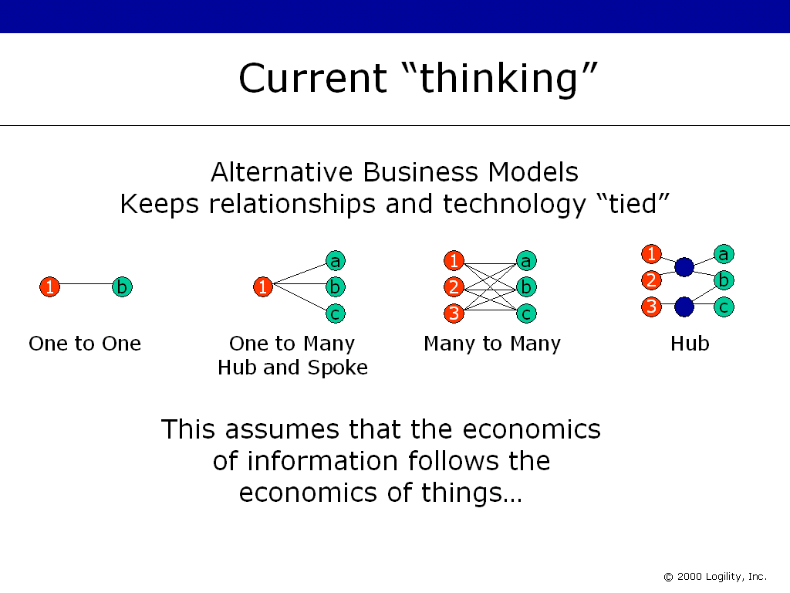

Figure 1: Current thinking limits understanding
and opportunity that now exists in e-Business.

These simple terms are generally described as follows.

- One to One (Internet-enabled Electronic Data Interchange, or “e-EDI”)

This represents the pre-Internet era and often draws out a review of Electronic Data Interchange. Even if EDI were not used this model still fits the “Old Economy” as this refers to the series of “point to point” relationships between companies. Each company, buyer or seller, treated each partner as a discrete entity and all communications and processes were modeled in this way. Note that in this era, there was in fact little room for real B2B processes – all processes took place behind the company’s firewall. EDI was not B2B process, it was B2B transactions.

- One to Many (e-procurement)

One to many is typically talked about for e-Procurement or demand aggregation. This was generally applied to Indirect Materials – the things that all business need in order to operate such as pens, pencils, desks, health care, and so on. From the buyer’s perspective, the idea here is that several buyers can group together their purchase requirements with a view to increasing efficiencies in the supply chain by making more economical purchases (higher volume equals greater leverage equals lower unit price). From the supplier’s side, the chief benefit of this model is achieved by participating in such an environment to potentially increase revenue through efficient access to more buyers than in the old model. The costs if “finding each other” were lower than in the preceding Industrial Economy. However it is unclear if the increase in access (to new customers) offsets the loss due to price/margin erosion. This process may start as an anonymous one to many, but the transaction itself results in a one to one model; one buyer transacting with one seller.

To facilitate this coming together of buyer(s) and seller(s), a virtual marketplace is needed: the Net Market This implies an infomediary or intermediary – whichever is applicable. For such a Net Market to exist, it must eventually generate profit. For such a service to exist it has to have sufficient business being transacted such that the provider can make a living through “taxing” the business being transacted. This was thought by many to be derived on the transaction itself. However, since simple transaction management is a fundamental building block of many software and service providers, this is a highly replicable service and hence there has been observed a fast reduction in the likely transaction charges being made. Further, if the Net Market is unable to attract sufficient buyers and sellers anyway, the market will not gain critical mass sufficient to generate enough revenue. It will collapse – not unlike a White Dwarf!

- Many to Many (e-Markets)

This model is a natural extension to the previous model. The typical discussion here centers on such processes that relate to how buyers and sellers find each other, or in New Economy speak, e-Marketplaces. In other words, the processes that precede the transaction. These processes include RFP/RFQ and auction or reverse/auction models. In an anonymous manner a prospective buyer posts to a market a desired requirements. This may be a simple “order” or may include some engineer-to-order or make-to-order elements such as product specification or certification requirements. Through some powerful rules-based process, suppliers are interrogated and ranked and then presented to the buyer for review. Price figures heavily in this process although recently most of these providers have purported to add some workable alternatives such as vendor performance, conformance and reliability metrics. The whole process up to this point generally is anonymous.

The buyer then will select a seller. However, in some cases there maybe no commitment to place the order. In numerous cases today, the actual transaction is consummated outside the market, as the provider of the technology has not yet implemented software to complete the business cycle. The transaction itself may be a simple, single order or may be a contract over a lengthy period of time. In either case, the benefit is associated with the speed and cost of how buyer and seller pair. Economists call this the transaction cost.

In summary, one-to-many focuses on the reduction (some call “optimization) of transaction price (product or service) and transaction cost (the processes that bring buyers and sellers together). Combined, these models offer tremendous savings for most buyers and sellers. By aggregating “demand” across multiple buyers, better efficiencies in purchasing can be achieved. This represents an overall reduction in costs in the supply chain.

The AMR Report on Supply Chain Management, June 2000 entitled “Get your Supply Chain Processes Ready for Trading Exchanges”, outlines four business models for Trading Exchanges (or Net Market):

- Independent Trading Exchange (ITE),
- Vendor Trading Exchange (VTE),
- Consortium Trading Exchange (CTE), and
- Private Trading Exchange (PTE).

In all cases the “data” that flows through the exchange from company to company mirrors the flow of “product”, and is in fact tied to it. The most important piece of information that flows from buyer to seller – the primary purpose of the exchange – is the Customer Order. The Customer Order is tied to the physical boundaries imposed on it by the product that it is related to. Indeed, it is the “trickle down” affect of Customer Orders, as they meander their way to the next seller in the Value Chain that gives us the very name – “chain.” Customer Orders (representing the Demand Chain) drive the Supply Chain. EDI was the epitome of a very fast but still mirrored information flow. The distance between the product flow and the corresponding information flow was very narrow.

This simple view does not facilitate enough understanding of the new business processes that are emerging. The Internet has fundamentally changed the way information is moved, shared, copied and used. The data flow can and should be separated from business relationships; cognitive real estate can be organized very differently than the real-world marketplace. This issue leads to a more sophisticated model. The economics of how information is used has changed – for the better. This forces a re-think of the business models that were themselves only defined eighteen months ago!

What’s wrong with the older models?

Most Industry Analysts, Financial Analysts and solution providers now recognize that “collaboration” is the next “big thing” in the New Economy that will offer additional and perhaps greater benefits over and above what has been conceived of before. However, it has not been an easy journey. Most have recognized that the Internet can change many things, but in the rush, few have taken the time to recognize the true value of this new environment. In our haste, the first phase of the New Economy was mired in “EDI over the Internet” discussions of early 1999. I remember going to a seminar presenting collaboration as a major initiative. At any conference in late 1998 or early 1999 you would have struggled to find a presenter talk about anything other than EDI and the additional savings that will be achieved by moving such transactions over the Internet. Then we had the “catalog wars” in which most e-Business initiatives focused on the savings that would be achieved by moving paper-based catalogs onto the Internet.

Then the next wave was to take over “transactions” and move them to the Internet. XML played its part. Today, there are numerous organizations publishing their own XML-based standards for Purchase Orders, Customer Orders, Advanced Ship Notices, and so it goes on. The goods news is that this will provide savings for those companies that use these transactions (which is most companies). The bad news is that these are not new processes. They are simply “using Internet technology” rather than “exploiting” the Internet. XML is the key here. The real value from e-Business is to define new processes that use XML as a foundation for B2B interoperability.

Today we have evolved to the discussion of collaboration. Collaboration, beyond the hype, is described as “any process whereby business information (such as a business plan, sales forecast, replenishment plan, promotion plan, product design etc.) is jointly derived, jointly affirmed, jointly planned, jointly executed and jointly measured against by all interested parties.” We sometimes say that collaboration “changes the transaction between buyer and seller and hence the nature of the relationship between them.”

There are several good examples of collaboration. Product design is an opportunity where collaboration between stakeholders can benefit each other. Collaborative Planning, Forecasting and Replenishment® (CPFR®) is a new business process that is industry-neutral for buyer/seller direct material procurement planning and replenishment. CPFR assumes that the buyer and seller have “found” each other and a relationship exists between them.

Collaborative Planning, Forecasting and Replenishment® and CPFR® are registered Trade Marks of the Voluntary Inter-Industry Commerce Standards (VICS) group; www.vics.org.

The older Business Models outlined above focus on the transaction and how it flows between buyer(s) and seller(s). It does not provide an environment to talk about new business processes that are shaping true collaboration. I have in previous papers outlined the basic characteristics of the exchanges or Net Markets as:

- Many to many
  - Anonymous sourcing (although not essential)
- Price as a key decision factor
- Transactions are the focus rather than the Forecast
- Products are not differentiated
- Fulfillment is generally homogenous
- Continuous innovation
  - Automating old business processes
  - Leveraging Enterprise Resource Planning, (ERP) and “traditional” use of Advanced Planning and Scheduling, (APS)
- Self-service based
- Participants all use the same services and therefore the IT component of their business tools become standard across their competitors and cannot therefore form any part of their competitive positioning

Source: Rise and Fall of Trading Exchanges, Logility, 1999-2000

None of these characteristics support collaboration as described above. And more importantly the older models confuse the use of the technology that supports this change in the “relationship between buyer and seller”. Indeed, we need a new dimension to determine where the greatest profit and hence liquidity can be realized in a Net Market.

The New Framework

The new framework we propose is made clear when one realizes that the old models listed above merge technology formats and data flow models with business and relationship models. This was fine for simple “transaction” level B2B activities, but for collaborative models, this is unacceptable because it is too narrow in its view of business relationships.

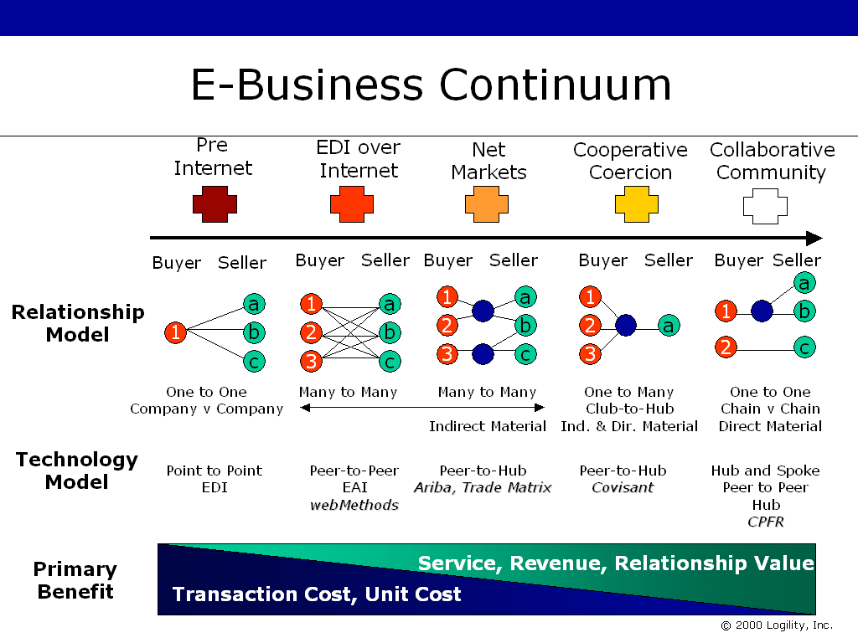
Figure 2: The Intersection of Data Flow and Relationship Models

Moving from left to right: the pre-Internet age was a time dominated by “EDI as the objective.” This was a time when companies sent business documents to each other – typically via fax. Electronic Data Interchange (EDI) is a point-to-point technology supporting a one-to-one business function. EDI is also point-to-point technology that sped up the slow fax-based model. It exists physically between two and only two companies for the purpose of the document transaction. A company may use EDI with all of its suppliers, but it is not a one-to-many model in any manner; no benefit is derived from the fact that you were using EDI to achieve operational efficiencies. The data and process (if you can call “exchanging data” that) are one and the same.

The next period was dominated by “EDI over the Internet” discussions. This is a many-to-many model where each “node” or peer can transact business with all its customers or suppliers using the same standards-driven document format. The EDI files or transactions can be moved over the Internet rather than over dedicated lines. The reason to move EDI over the Internet has more to do with economics than with strategy. Just 24 months ago, EDI over the Internet was presented as a strategic issue. Now most people realize that it is nothing more than an economic question. Technology was peer-to-peer for the same reason that it was point-to-point. With the advent of the Internet, a user could conceivably exchange the same documents with many more customers and/or suppliers.

The trading exchange or Net Market (or hub) was introduced about 18 months ago to facilitate the gathering of greater numbers of buyers and sellers. For many of the initial data flows and processes, it remained an aggregated set of one-to-one relationships. Online Catalogs were positioned as one-to-many with personalized information effectively maintaining one-to-one activity. Online auction models are in fact many-to-many business processes that require compatible (implying standards-based) peer-to-peer data flows.

Companies that class themselves as Application Service Providers (ASPs), Integration Service Providers (ISP), or the newer Business Service Providers (BSP) can also market effectively this many-to-many service. These companies provide outsourcing services, hosting services and even managed application services. The point is that these new business models also support Net Market models. The hosting of a Net Market service is not too far from the hosting of an outsourced business application. There are huge differences in some elements, such as security, scalability, and integration etc. but the principle is very similar.

Further, these Net Markets are now competing among themselves. Certain factions of buyer/seller groups are congregating at certain Markets within the same industry – and now competition is building between these massive conglomerate value chains. A Value Chain here signifies a synchronizing of demand chains (customers and their customers) and supply chains (suppliers and their suppliers). The very foundation of a Net Market is to promote competition across the supplier base (for supply in Buyer-centric Markets) and across the demand base (for orders in Seller-centric Markets). They are designed to eliminate barriers to entry, to prevent price fixing (due to any influence of participants) and to reduce or eliminate transaction costs. They are, in essence, the models for perfect competition.

Note also that for the last nine or so months, providers of these Net Markets have been striving to make a profit. If the Net Market is unable to attract enough buyers and sellers, and derive insufficient funds to perpetuate the Marketplace – evolution takes over. Therefore, much has been written on the priority a Net Market should place on profit, and how they should attract it. However, profit has peculiarities at this stage of Net Market evolution. The new models that focus on collaborative business models DO NOT have the same need to seek profit drivers. This is because the link between technology or data flows and business models or relationship models is broken! Seeking to charge a fee on transaction-based Net Markets is a no-win solution as the pressure to reduce margin and provide a competitive Net Market will ensure the lowest possible profit for the Net Market. Buyers and sellers have fleeting allegiance to each other by design.

Collaboration on the other hand, is different. And because of these differences (shown below), profit will follow. Net Markets create perfect competition environments. The vary reasons that make a Net Market successful will the same reasons why it will fail; as it provides an environment in which buyers always make rational decisions on perfect information and all buyers and sellers are free to enter and leave the market, competition will become transparent: it will disappear!

Competition must survive and through differentiation it will. Differentiation will be provided in two forms: the simpler or transparent model provided by Net Markets that focus on process that simply match demand to supply and by Net Markets that focus on processes that streamline and re-engineer the whole value chain through collaboration.

However, most analysts focus so heavily on traditional business models and assumptions that they have yet to spot this anomaly. AMR who defined much of the New Economy structure through rigorous and exceptional analysis has so far only focused on the traditional model – that of the “transaction.” Their business models “fit” into this paper’s overall model as shown below.

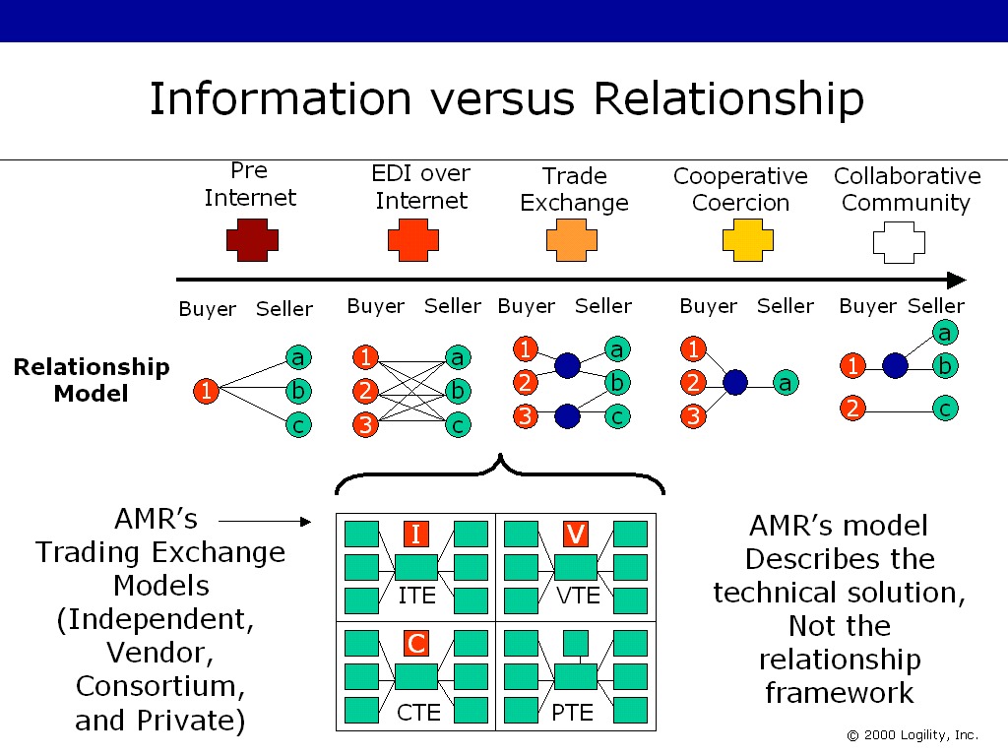

AMR Material Source: Get Your Supply Chain Processes Ready for Trading Exchanges, Robert Ferrari, The Report on Supply Chain Management, June 2000

Figure 3 AMR’s ITE, VTE, CTE and PTE business models are simple “data representations” and do not support the disintermediation of information and things. With that disintermediation, the relationship becomes more important than the things. Collaborative processes may take place on any of the AMR models; who “owns” the “server” is irrelevant although still important.

The collaborative models are in fact one-to-one or one-to-many in all cases (which sounds awfully similar to EDI!). They are, by definition, private whereas the previous model was public. Barriers to entry are designed into the relationship (creation of a value chain) as a source of competitive differentiation whereas in the former model those barriers are eliminated, which facilitates perfect competition across the supply chain.

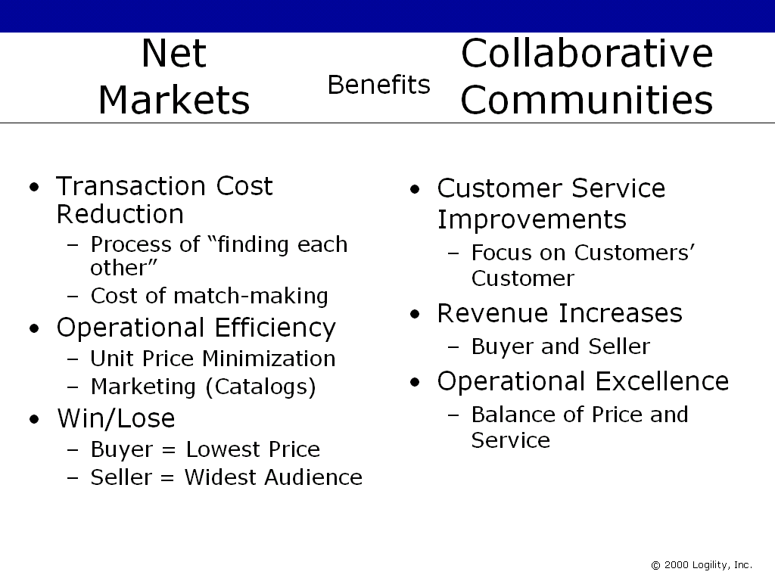
Figure 4: Benefits are conjoint and complimentary.
Net Market benefits accrue in public environments;
Collaborative benefits accrue in Private constructs.

In the above graphic you can see that the primary benefits of these “competing” models are in fact complimentary. Net Market benefits are focused on Transaction Cost reduction and generally “buy-side,” demand aggregation features such as price leverage. They are derived from public business models that focus on perfect competition. Sell-side providers generally cross the divide and support collaborative processes that favor both the customer and the supplier. In B2B, both have a mutually supporting job function. Any company needs access to both business models.

From a technical perspective or data flow model, any previous model can be used to achieve collaboration. A buyer may go to a hub (Net Market) to collaborate with its partner(s). They may host their own solution (here called a hub) and allow their partner to access it directly (each acting as spokes to the hub). They may integrate their systems to their partner(s) system (peer-to-peer). In other words, the business process is different from the data flow model. This is new, confusing, and few people grasp the important differentiation.

The last graphic in figure three (above) demonstrates clearly the separation of the economics of things versus the economics of information. The Business Model and relationship for collaboration is really a series of one-to-one activities that result in a one-to-many or even hub-based technical infrastructure. The retailer will not collaborate horizontally with other retailers and neither will the manufacturer collaborate with competitors. But the technology used in each case ensures that there will be numerous “touch points” for integration between buyer, seller, trade exchange hub and net market. There follows an example.

CPFR is a business model that facilitates several truly collaborative processes between buyers and sellers. There are technology solutions that are coming to market that a buyer and/or seller may acquire in order to implement CPFR on a scalable basis with many of its trading partners. Also, Net Markets are being set up that may also offer this CPFR technology as a service. Therefore buyers and sellers have choices: should they ignore CPFR (not a realistic option), should they acquire their own solution, or should they pay to obtain access to the technology hosted on a Net Market?

Since the market is so dynamic, the number of Net Markets that will “make it” is unclear. Knowing who of the current Net Markets will make the Winners Circle is also very hard. Acquiring one’s own solution insulates a company from the changes that may take place in the market. Therefore, when we consider the Consumer Goods industry, we might envisage a future state that looks like the diagram below:

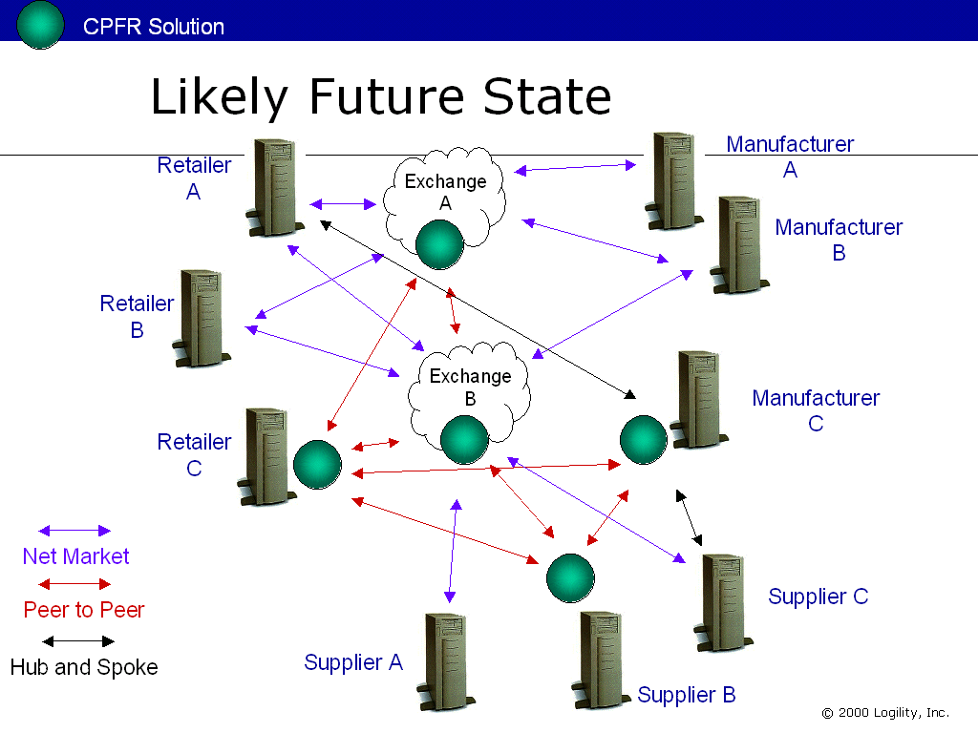

Figure 5: Likely future state of CPFR; here multiple buyers, sellers and suppliers are shown transacting B2B in various collaborative modes; two Net Markets also act as clearing houses for some companies; those companies that acquired their own technology are insulated from whatever technology is used by its customers or suppliers or Net Markets it works with.

The Race to Profit, and the Mating Game

Short Term Concerns versus Long Term Viability

Logility has been explaining the difference between a forecast and a customer order for over five years. With the advent of the Internet, the point is even more valid. However, there are some people who get it, and some who do not. The following will help explain why we introduced a metaphor below to demonstrate the different between forecasts and customer orders, true collaboration and transactions, over the Internet.

About two and a half years ago I had the good fortune of meeting a Senior Vice President of R&D for one of the largest Enterprise Resource Planning (ERP) vendors. Logility presented and demonstrated a product that allowed a supplier to collaborate with a customer over the Internet – thus eliminating the need for the manual, labor-intensive processes typically associated with placing and managing Customer Orders. The Senior VP was aghast! After thinking the issue through, he came to a momentous conclusion. “Why not collaborate on the customer order, and therefore eliminate the forecast?”

He and I locked horns for a short while as we battled each other from opposite ends of the opportunity. His systems and his company were transaction-bound; he thought that ERP was the end, not the means to the end. He was stuck in the “B” part of B2B. I on the other hand came from the “2” part of the equation and was trying to use a different piece of information to facilitate a better relationship so that the customer order “transaction” would in affect “go away” or at least be automated. Needless to say, we did not get very far. He retreated into his ERP cave and I into my black box. We recently introduced the following metaphor to help explain the true value of collaboration as a value-add service to Net Markets and a primary way to generate profit. Indeed, since we have been talking about this issue months before this paper was published, it is likely that several Net Markets will have announced plans to adopt collaboration as the major profit making service of their offering.

To explain why profit will follow collaborative processes and not transaction-focused Net Markets, we need to use an analogy that is closer to our personal lives than business. To keep things simple, we will talk about sex and marriage – most of us should understand this.

Our Net Market is a nightclub. The dance floor and bar are the place where buyers and sellers go to transact business. “Business” here is “a date.” The buyers and sellers are men and woman who “find” each other at the Night Club. Please note that this paper is not designed to define morals or values, or religious in any manner, and it makes some sweeping generalizations. You will have to bear with us to get the point.

We are going to assume that many men and woman have the same goal of getting married and they feel that the benefits of getting married are significant. A given boy or girl can have one of two perspectives: they can act honestly and seek partners who desire an ongoing relationship with the ultimate goal of marriage – known as a win/win. Or they pursue opportunistic relationships where they cheat, where, at the conclusion of the evening they part company. The cheater may feel they have won as they might achieve their goal of a one-night stand; the non-cheater may feel that they have lost as they invested in the relationship only to be disappointed. This could be described as a win/lose.

In reaching the goal of marriage (a strategic relationship) it is likely that men and women have to date several partners in search of the “right one.” Some of those dates comprised of two people honestly seeking the “right one”; some of the dates comprised of a cheater. In some cases a date might in fact comprise two cheaters! If they are “honest” partners, this process of searching is innocuous, open, and fair.

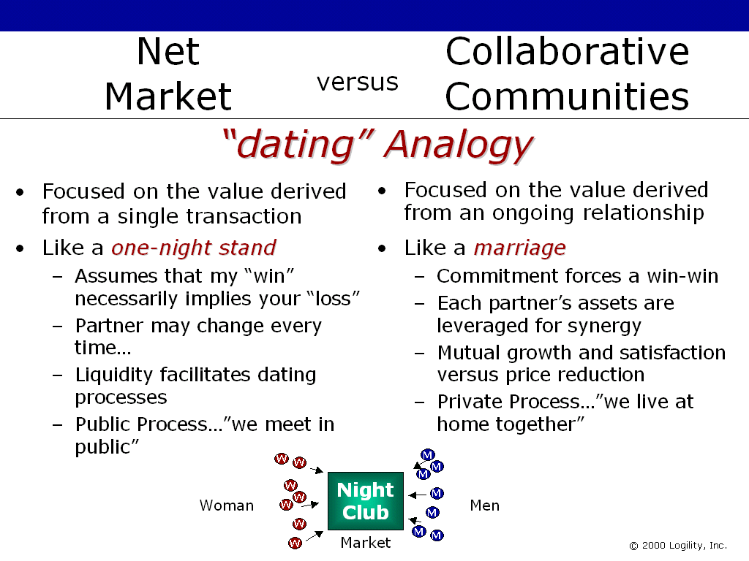

Figure 6: A nightclub acts as a net market for dating

The “transaction” here is described as the benefit that both parties derive from a single event or date. In the case of a first date that ends with the “thanks, but no thanks” the value may have been a “reasonably fun evening.” With a continuing relationship, it is expected that things may have gone rather well. With ongoing success, the advent of a proposal presumably means mutual benefit and a strategic or emotional alignment is being sought. Marriage is the fulfillment of that relationship – a contractual agreement between the two parties that is a mechanism to provide for a long-term strategic relationship and family commitment.

Every night the club opens and charges a small fee for men and woman to enter. In truth, as equals the man and woman as roles are interchangeable and prostitutes do not figure in this metaphor (not in this paper, anyway!). The fee charged is part of the income the nightclub gains from running service. The nightclub also offers other value-add services such as providing food and beverages.

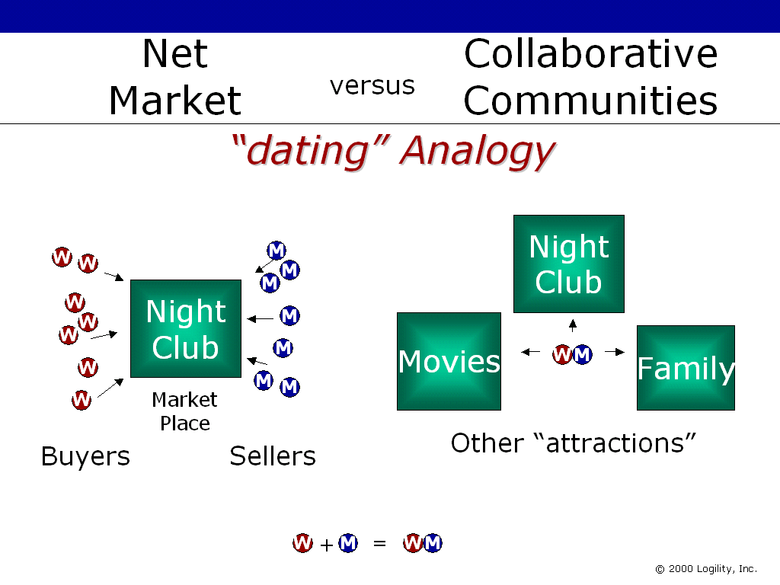

Figure 7: Groups of woman (buyers) and men (sellers) congregate at locations that promote “dating”; the fee paid to “date” is what contributes to profit and the numbers of men and woman attracted constitute liquidity. Ladies Night is a marketing event to increase liquidity and hence profitable activity. As men and woman “pair” up, they have a greater choice of activities that include other venues. However, they may still go “night clubbing” from time to time. This represents new forms of B2B transactions.

Sometimes men and woman group together in associations. One function is to trade information and compare notes. Sometimes friends act as intermediaries in order to introduce buyers to sellers and so on. The point is that during the evening, buyers and sellers meet and in some cases, business is transacted. The buyer and seller have a choice – depending on their motivation.

If a buyer is not interested in the brand (stereotype) of the supplier, if they are focused more on reducing the costs of finding sellers (transaction cost), if they are interested more in their own personal objectives with minimum concern for their partner’s satisfaction, or even at their expense, then this buyer could be said to be seeking a one-night stand. He/she would simply “go through the motions” with a view to transacting the event and then moving on to the next encounter. The subsequent encounter could be with the same partner or another (in the business world) but in this scenario, the “loser” is unlikely to want to transact business with this “cheat.” Unless however the partner is likeminded in which case the buyer and seller continue to meet in an opportunistic manner. The repeat the one-night stand.

Cheating is defined here as a person that appears to have honest intentions with respect the dating processes but who in fact seeks to maximize their return at the expense of their partners; this provides a “my win necessarily implies your loss” scenario. This contrasts to marriage, which might be said to be “I win, you win.” Being married for 5 years, I am testament that I got the best deal and I hope my wife never reads this paper!

A one-night stand is analogous to a purchase/customer order. It is a single opportunistic transaction between buyer and seller that takes place at a given moment in time. Leverage of past transactions has little impact outside of price negotiation. Who the parties are therefore is most times of little consequence. What is more important is the fact that the transaction took place and that each party thinks that they left with the best deal they could extract. If I am the buyer, I want the lowest price. If you are the seller, you want the highest price. If truly do win, I get a lower price and you get caught. If you truly win, you get more money and I get a worse deal. Demand and Supply is optimized at a given moment in time; this is what is called dynamic pricing.

Buyer and Seller will go their separate ways after the one-night stand. They may or may not meet again. If another similar transaction is to take place, they may meet to replicate the event. They may not. This is of little consequence to either party or the transaction itself. If they did happen to meet again, they would simply repeat the one-night stand.

The corollary to this is that the boy and girl meet and decide to maintain a long-term relationship in marriage. The purpose here is that boy and girl forsake the opportunistic benefit they would ordinarily expect from a series of one-night stands and plan for a greater benefit from their synergy, trust, shared and mutual goals. In the business world, they forsake a series of deals where the price and transaction cost reduction is the main goal (from the buyer perspective) and they try to create some more revenue through tighter relationships that result in better customer service. This may even result in increase market share at the expense of those competitors that have not entered into such strategic and collaborative relationships.

Over time, each party should gain a perception that they have “won” several times (and maybe “lost” in a few cases – let’s be realistic here). Hopefully they will feel that net-net, they are in a better position. Marriage is by no means perfect (remember – this is not a moralizing story). In business, a partnership is not always a honeymoon. Indeed, the majority of business-to-business partnerships or alliances are more paper-based then real. Only when emotional alignment is attained will both parties need a partnership. This emotional alignment is the vehicle that nurtures mutual success (win-win). A strategic relationship occurs when both companies have shared objectives that remain in line, even if they may change over time. Should they diverge, the partnership cools and may even beak down or stagnate. The past is littered with so-called partnerships where each party assumes that only a trade is taking place. This is not a collaborative partnership. This is a transaction relationship.

The marriage contract and the love that flows between the buyer and seller are the barriers to entry – legal and emotional. Should the love fail, both parties end up (possibly) looking elsewhere to meet their needs. Legally, the agreement might be terminated and that would facilitate a new agreement with new partners. This is no different from long-term strategic relationships between companies.
After the first date, the couple may end up going to other venues and participate in other activities. In other words, they do not pay the door charge at the nightclub – they may pay for dinner or go to the movies. Or they may stay at home. In other words, when a collaborative long-term relationship takes place between buyer and seller, it persists. In this analogy it is the natural order of things. The Net Market Nightclub is no longer required. In business, this might be represented by a change in the transaction between buyer and seller. Instead of paying a Net Market to use the services of Purchase Orders/Customer Order Management solutions, they may end up requiring less of this technology and want to automate the procurement planning and replenishment with other solutions that are collaborative in nature.

So with the dating process in full swing, the nightclub is no longer the center of attention for collaborating buyer or seller. They may attend now and again and enjoy themselves. The nightclub however needs buyers and sellers who are interested in either marriage or one-night stands (the two extremes this analogy supports); the pair (when established) does not need it. The Net Market needs profit in order to maintain the pairing processes; once relationships are established and ongoing, partners may still attend the Net Market – but they do not use the pairing or dating services. They now want to do other things. In our business scenario, this is what we call Collaborative Commerce.

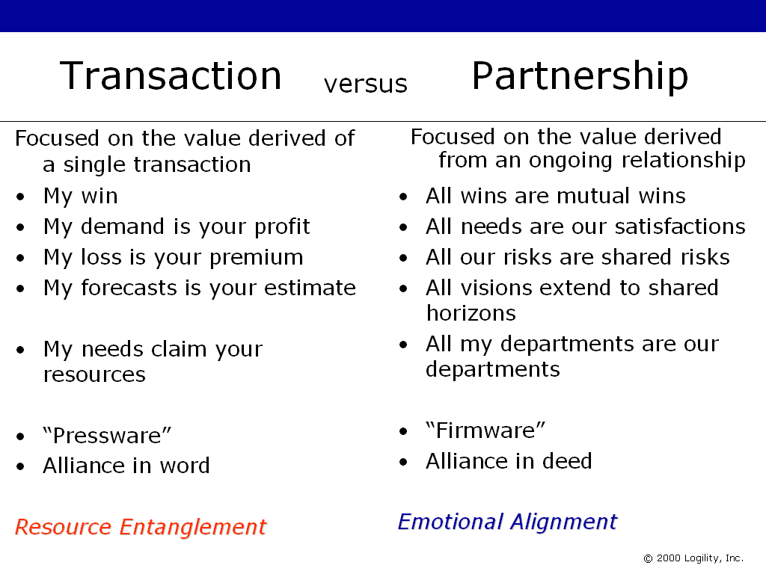
Figure 8: The falsehood of “partnership.” When emotional alignment is achieved, synergy is real. When not, partnerships move beyond the honeymoon phase very quickly and devolve into stagnation and then retribution and then silence. Marriage is the model. A partner can have many dates (press-release-partnerships) but few marriages. Arrange announced partnerships in a ‘mind map’ and seek to find the emotional ties. All too often relationships extend beyond little further then the “press-ware” used to announce them.

Figure 8 emphasizes the extremes of the success and failure of partnership. All too often companies use the term partnership and yet in reality what might start out as a plan falls all too short. This is because emotional alignment between the two breaks down. The extremes shown above demonstrate how each “camp” would or could rather rudely describe each other’s perspective.

Back to the Nightclub. Profit is required by the nightclub in order to remain open. In the case of the dating game, they facilitate the process whereby buyers and sellers find each other. This is a valuable service. After they have found each other, a relationship is established. This relationship is assumed to derive great benefit. But how or why would the new pair go to the nightclub? This is where the concept of “stickiness” comes on. There has to be a reason for the pair to come back to the nightclub else the revenue stream for it will remain very low or negligible. Repeat business that provides win/lose scenarios will give way to business that provides for measurable win/win scenarios. This later scenario provides a reason for the buyer and sellers to continue to transact business at the Net Market.

Moving somewhat beyond the analogy, you should now recognize that when buyer and seller collaborate they are changing the process between themselves. They are both seeking a longer-term relationship that does provide a win-win result. They are giving up their single status and announcing an engagement to be married and actually getting married. This has ramifications for supply chain and value chain management.

Not that in the case of those businesses that negotiate medium term contracts as in the case of contract manufacturing where capacity is typically planned ahead of known product or material requirements, a hybrid marriage certificate is used. There is more commitment over a single transaction, but there is less commitment than a full marriage. It’s like a long-term date!

Benefits to date from early examples of collaboration far outweigh those accrued from transaction-focused Net Markets. Such benefits include impressive cost-cutting and efficiency savings related to inventory, cycle time, and obsolescence reduction. Additionally increases in revenue have been observed that have come about as a result of massively reducing out of stocks at the customer location leading to improvements of customer service. Interestingly, depending on the growth of the market, this might even represent an increase in market share versus a simple growth of the whole market. This has major ramifications for saturated or mature markets.

Figure 9: Standard Contracts have moved beyond such intentions,
but for the heart this can be a daunting commitment.

When a buyer is collaborating with many trading partners, they are creating an environment that value can be added via collaboration, and this implies a profitable opportunity for a provider of such technology. As long as the buyer/seller are not focused exclusively on price reduction and transaction cost reduction, a profit can be generated. When customer service and revenue are as important as price reduction and transaction cost reduction, the provider of the technology can create a self-sustaining business model. For Net Markets that exclusively focus on simple transaction-based models, a continuous rive to margin erosion will ensure that will cause them to seek alternative business models to support.

Typically in an extranet a buyer and seller are transacting business over and over again in a closed, private manner. If this buyer and their partners were to now “do” this work on an Exchange that offers this service, they will in effect bring business (and implied profit) to the Net Market. If you believe as we do that collaborative commerce is part of the future, this is going to happen. The Net Market simply acts as a hosting service or outsourcing service. The point is that collaborative commerce will take place. The only question is where? If the Net Markets don’t adopt it, the buyers and sellers will simply take their business elsewhere. And if this were to play out in this manner, Net Markets will be relegated to managing the lower hanging fruit of indirect material procurement.

Lastly, there is another opportunity here that is often overlooked. For several years now companies have strategically been reducing their supply base. This has come about for several reasons. However, collaboration fits in well with this strategy and in fact is the strongest business model that supports such a strategy. The main issue is, remember, focused on the characteristics of the acquisition process. For commodities that have many sources of supply; who’s demand is price sensitive, and typically un-branded, traditional “one-night stand” providers are excellent. For branded or differentiated products, with fewer sources of supply, “marriage” is a better model to exploit – for BOTH parties!

Summary and Conclusion

Profit is the primary focus for many Net Markets today. Few of them even transact any business at all! Venture Capital funding is still available – for prudent business plans – but investors are no longer falling all over themselves to provide the funds. A couple of “dot com” companies have gone belly up. Several Net Markets have made lay-offs, delayed release schedules or merge with competitors. This is not the sign that the New Economy is doomed. In any good growth year, 40 percent of all new businesses fail in the first five years! This period is really a mark of the change in the business cycle. We are not at the beginning of the end; we are at the end of the beginning.

There are several Net Markets already established in most industry verticals. Most experts suggest that most segments cannot support more than one or two large Net Markets. All analysts predict that there will be a consolidation. With that point in mind, and the ever-pressing need of Net Markets to show revenue and profit-making business models, liquidity is key. In other words, where Net Markets spend their management time has shifted. Instead of focusing on strategy and assembly of strategic partners and providers, now customers and suppliers are being sought more heavily. Without profit, they will be doomed. Or so conventional thinking has gone so far. Hopefully this paper has shown that collaborative commerce what will drive the revenue growth of B2B and therefore Net Markets that focus on serving this need will attract their own liquidity, hence profits and so on.

This paper has tried to show that collaborative commerce is in fact the first business phase that exploits the use of the Internet rather than just using it as a faster, quicker, cheaper carrier of old economy transactions. With this in mind, this paper had an ulterior motive – to help Net Markets realize that they can and should look to collaborative commerce for:

- Competitive Differentiation
- Rounding out support for Direct Material Procurement Planning
- Self-sustaining liquidity

The first few Net Markets that add Collaborative Commerce to their stable of services will attract revenue that is being transacted in multiple single, one-to-one environments. This means Net Markets can use Collaboration as a way to inject profit into their business and side step the already burgeoning onslaught of the numerous transaction-or catalog focused technology providers. The point is that companies have a choice where to transact business – both the old economy transactions (purchase order, customer orders) and the new economy transactions (CPFR etc.). When Net Markets decide to support direct material procurement and fulfillment, and CPFR is provided, then they will attract profits. Price and transaction cost reduction services are admirable and part of the solution. But they need to be supplemented with Collaborative Commerce.

'Till death do us part has a special meaning to marriage. The vows are inviolate. For too long businesses have set aside these points when they enter into “partnerships”. They have focused too much on the transaction and not the subsequent relationship. For too long partnerships have in reality been fleeting cycles of dates and one-night stands. Hopefully this paper has outlined for you the need for true collaboration as part of any e-Commerce strategy and that Net Markets ought to view collaborative commerce as critical to their long-term success. Only trouble is that on Internet-time, “long term” really means short term. As Dan Van Hammond of Kmart likes to say, “the fast will eat the slow”. The search for liquidity is on – collaboration is a highly differentiated service that Net Markets can provide and with it they can generate profits that are not possible with transactional focused services. And if you don’t offer those services today, your competitor Net Market will.

Appendix

The Economics of Information and the Economics of Things

So why is collaboration so different to the older models, and why does the current framework break down when tested with collaborative commerce? In essence, it is concerned with clarifying the relationship between information and things (products and/or services). Until the Internet was recognized as a discontinuous technology the economics of information and the economics of things were tied together. Andy Grove, Chairman of Intel, calls a discontinuous innovation a “10 times change” in his book, “Only the Paranoid Survive”. Such technology breakthroughs derail the status quo and force a re-think of competitive situations. In his new book, “Living on the Fault Line”, Geoffrey Moore described discontinuous innovations as breakthroughs that relegate to the trashcan all previous successful models thus allowing new start-ups with little baggage to compete and replace the champions of the last technology breakthrough. This is a feature of the old Industrial Economy. The New Economy breaks the economics of things and information apart. Those that don’t recognize this change imperil their organization.

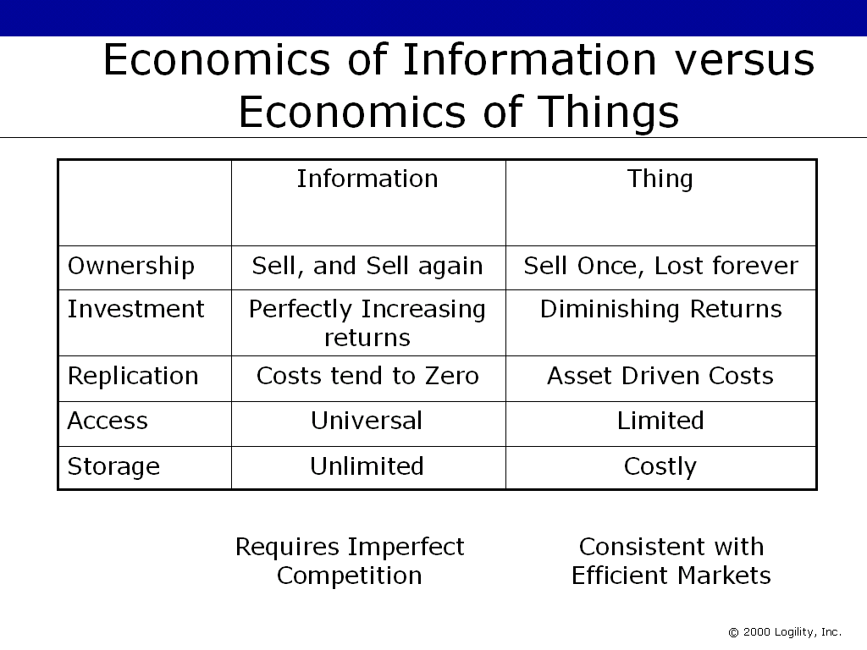

Figure 10: The value of Information outweighs physical assets in the New Economy.

In essence, information becomes the primary asset in the New Economy. Information in fact is the asset; it is used to describe the physical asset. Since the Internet enables the flow of information freely and quickly – far more quickly than the physical assets they describe. The value increases with the number of people that can use the information or who need it. Information describing consumer behavior (a forecast) becomes the primary focus of any Value Chain. A Value Chain here is defined as any series of Demand Chains and Supply Chains synchronizing their mutual efforts to meet the needs of the consumer. Customer Relationship Management becomes more important for B2C; and visibility through to the consumer through all B2B links becomes ever more important. Collaboration across a Value Chain was not possible on this scale before the Internet. This marginalization of the economics of things leads to a new framework explained below.

For things, a seller “loses” the item once it has been sold. The deed passes from person to person along with the goods themselves. For information it can be different. In the case of knowledge, the seller can pass on a “copy” of the knowledge yet “keep” a copy them-selves and re-use it. Things suffer from diminishing returns; I can buy an ice cream and enjoy the afternoon – but after three of four ice creams, I am about full of ice creams and therefore the additional value derived from each additional ice cream falls. Eventually it falls to such a level that I no longer derive any additional benefit and I cease to buy ice cream (at least for that afternoon). Once it is sold, it is lost. It has to be re-produced to be sold again. Information benefits from perfectly increasing returns in that the seller can sell it and yet still consume it and sell it again, over and over.

The cost of replicating data is very small. The cost of sharing information is also very small – certainly in comparison to the cost of copying and distributing things. Before the Internet, customer orders (information) were very closely aligned with products. With the Internet, new information that describes likely customer behavior (forecasts) is further detached from products in time and space. Remember that the distance between a customer order and the EDI transaction that described it was very narrow; with the use of the Internet, information moves much more readily to many more locations. However, there is little point using the “Customer Order” as the basic of a new business process; the “Customer Order” has a well-defined use – it describes a legal transaction for service: I will pay you “x” if you supply me with “y”. Forecasts describing likely behavior however are far more value able now as they can be shared with multiple layers of a Value Chain at the same time this eliminating time lag (reduced latency) and this making Value Chains more efficient and effective. In the future, the gap between the two will grow as more companies use that one-number forecast to better plan their internal and B2B processes.

Ease of access can be very high, and costs to access information can be very low. Things have to be physically located, or stored. Lastly, information can be stored cheaply – things cost money to keep in a warehouse. Some would even say that inventory is a substitute for information – because with poor information about customer demand, companies build excess inventory to protect themselves from that lack of information. This is why phrase “replace inventory and lead time with information” is so emotive. The business process of Just-in-Time resulted in too many Just-in-Case implementations because of this issue.

If you would like more information and a greater, in-depth analysis of the difference between the economics of information and the economics of things, you should read Blown to Bits: How the New Economics of Information Transform Strategy. This book provides insight and greater understanding of the value of information and inventory.

Bibliography / Sources

Blown to Bits: How the New Economics of Information Transforms Strategy, Philip Evans and Thomas S. Wurster, Harvard Business Scholl Press, 2000

CPFR Guidelines, VICS, 1998, www.vics.org, www.cpfr.org, 1


Get Your Supply Chain Processes Ready for Trading Exchanges, Robert Ferrari - AMR, The Report on Supply Chain Management, June 2000

Living on the Fault Line: Managing for Shareholder Value in the Age of the Internet, Geoffrey Moore, Harperbusiness, 2000

Only the Paranoid Survive : How to Exploit the Crisis Points That Challenge Every Company, Andrew S. Grove, Bantom Books, 1999

The Rise and Fall of Trading Exchanges, Andrew G. White, Logility, Inc., www.b2b-icommerce.com or www.logility.com, 1999

