AMST0210A-F09 QUIZ 10-23-09
- Who uses the term, “The Blessings-of-Civilization Trust”? What is the title of the document in which the term appears?
Author:
Title:
- Identify the author and title of the text from which the following passage is taken:

How has the photograph to the right been altered from its original? | 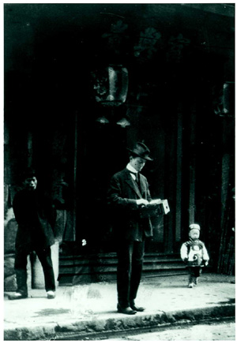
There is nothing to make one indignant in the mere fact that life is hard, that men should toil and suffer pain. . . But that so many men, by mere accidents of birth and opportunity, should have a life of nothing else but toil and pain and hardness and inferiority imposed upon them, should have no vacation, while others natively no more deserving never get any taste of this campaigning life at all, — this is capable of arousing indignation in reflective minds. It may end by seeming shameful to all of us that some of us have nothing but campaigning, and others nothing but unmanly ease. If now — and this is my idea — there were, instead of military conscription, a conscription of the whole youthful population to form for a certain number of years a part of the army enlisted against Nature, the injustice would tend to be evened out, and numerous other goods to the commonwealth would remain blind as the luxurious classes now are blind, to man's relations to the globe he lives on, and to the permanently sour and hard foundations of his higher life.
Author:
Title:

